Contact and non-contact forces

1 Cut out the five pictures and five labels at the bottom of the page.
2 Stick the forces in the correct boxes.
3 Stick the correct label below each picture.

Non contact forces

Contact forces

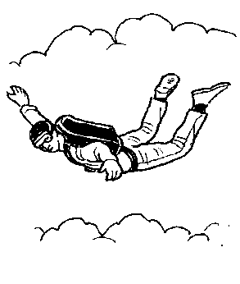 | 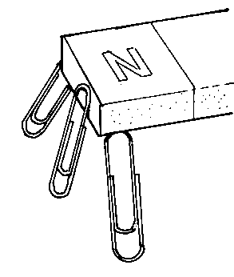 | 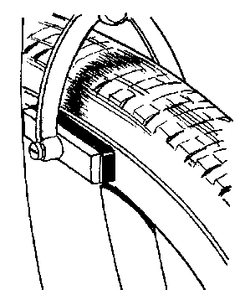 | 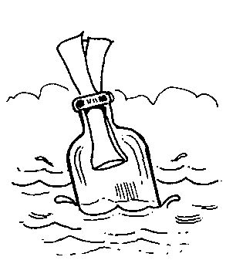 | 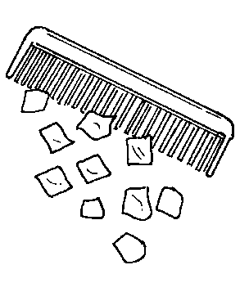

Magnetism | Static  electricity | Friction | Gravity | Upthrust

